Curriculum vitae

Personal Data: | 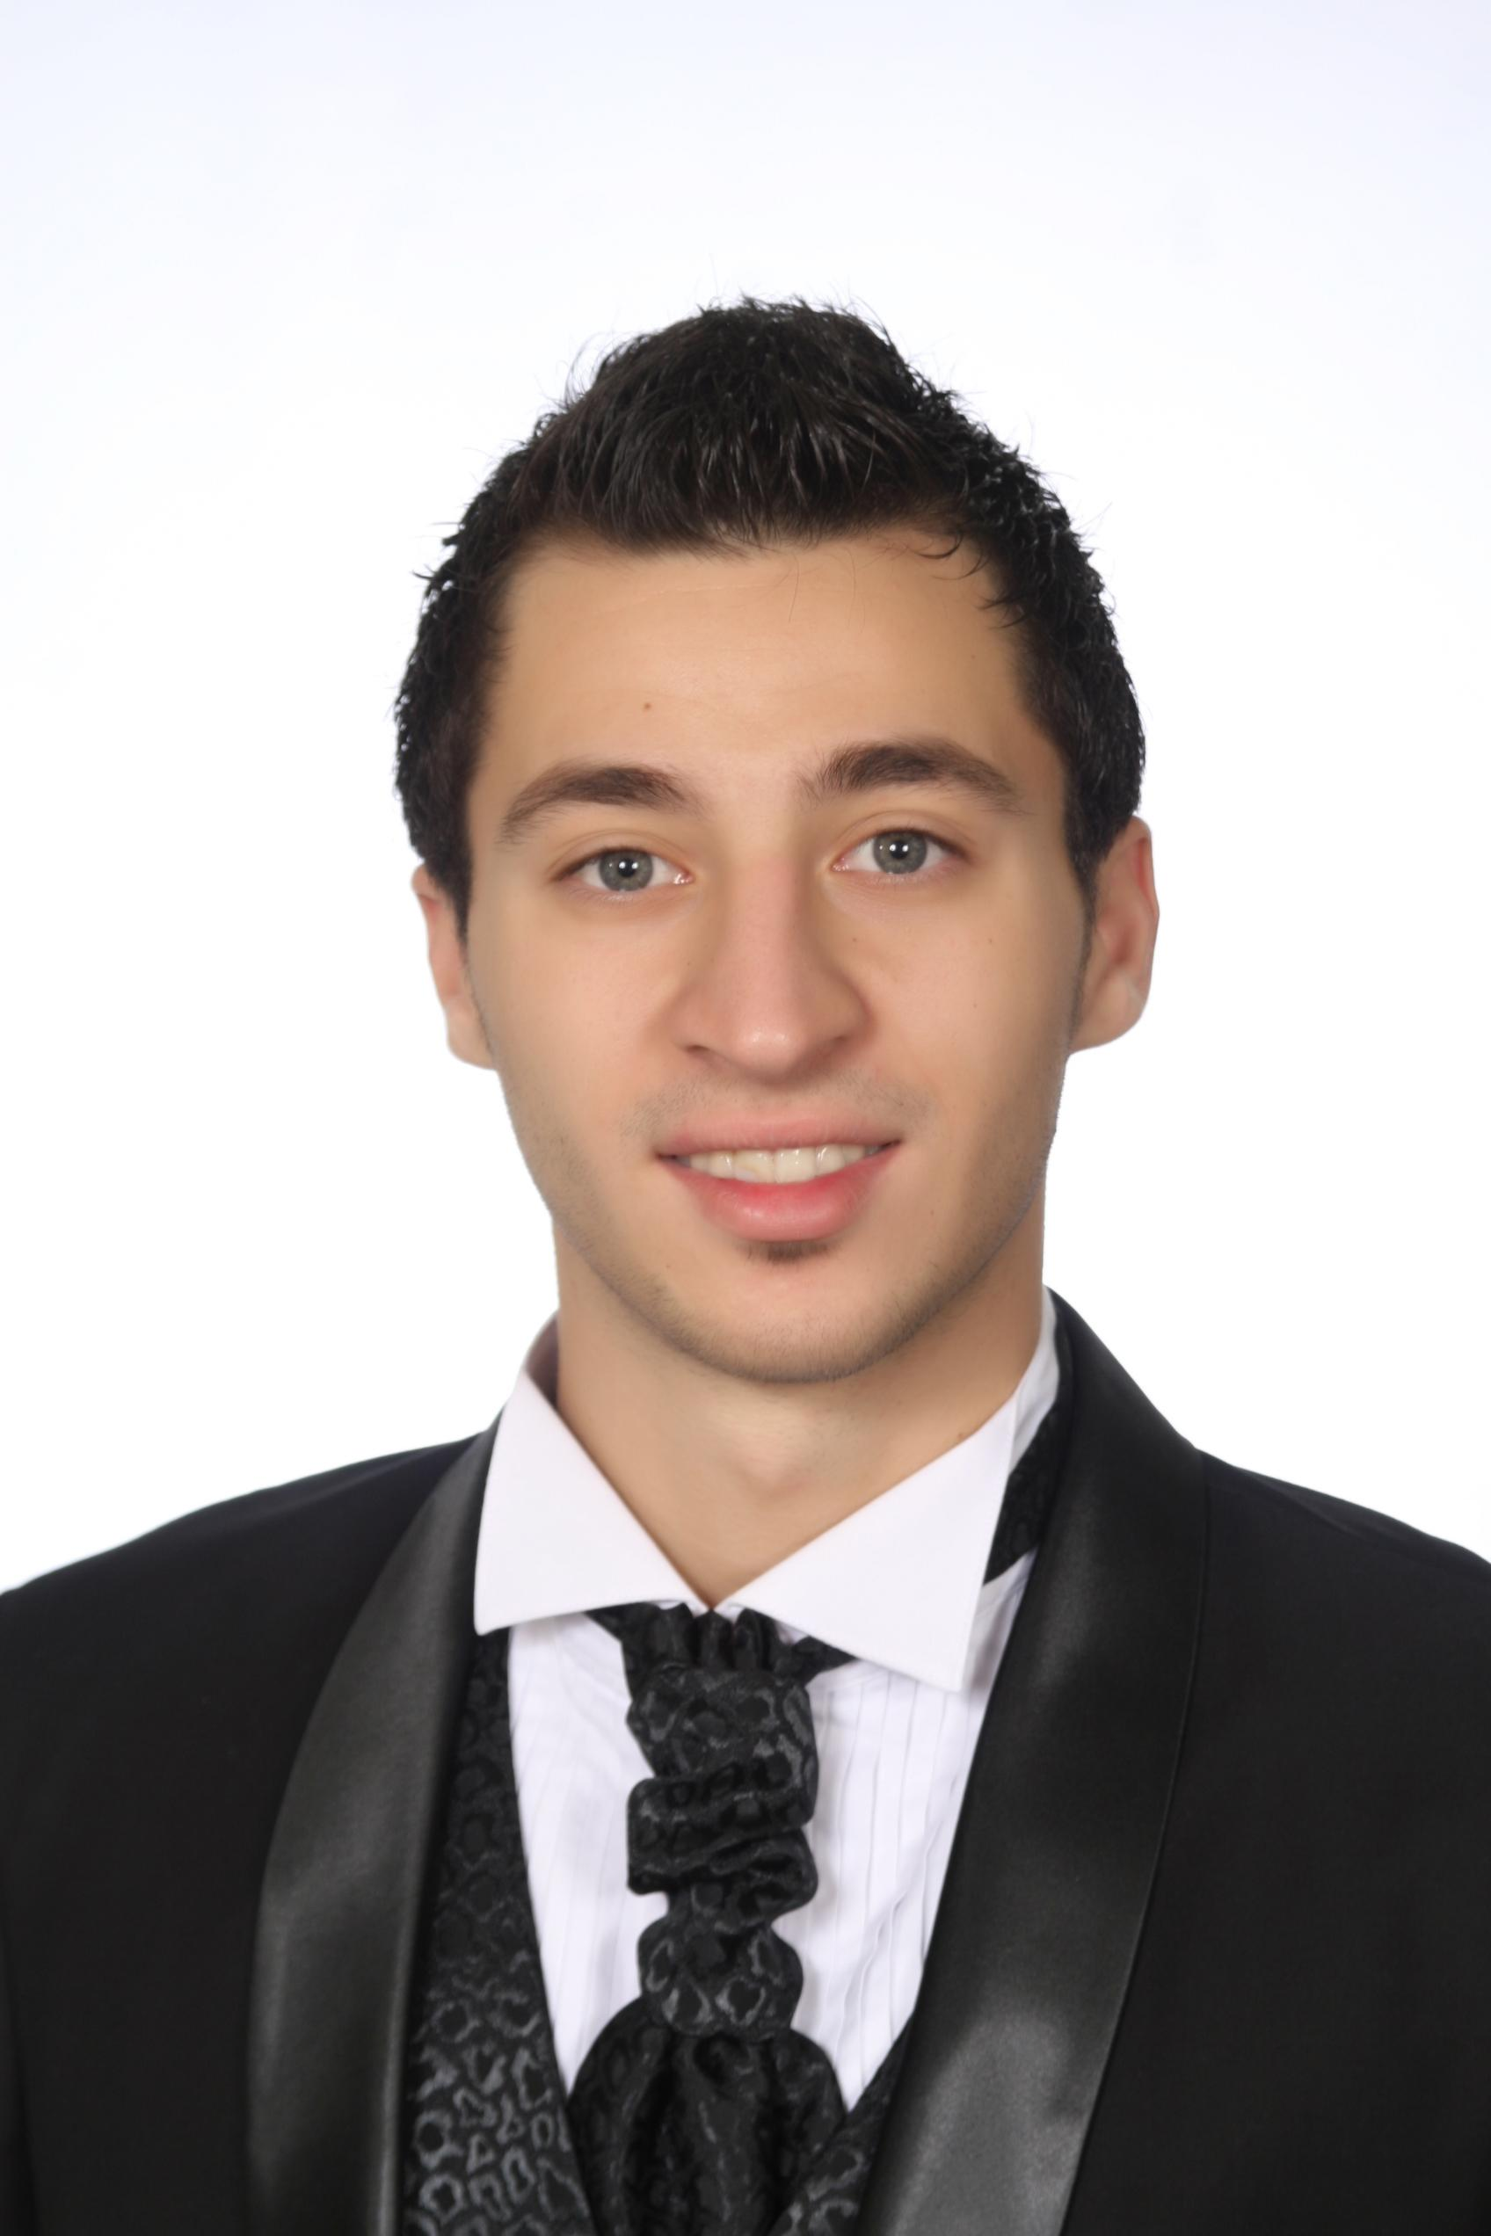  Name: Dominique Eid Abou Ghanem  Date & Place of birth: May 22nd 1990; Zahle, Lebanon  Telephone: +971-555575194  E-mail: dominiqueghanem@hotmail.com  Marital Status: Married  Citizenship: Lebanese
Education: | ٭ Hotel Management T.S (kitchen cuisine service, service table) [Phoenician Alphabet College, Zahle - Lebanon 2009 – 2012].  * Hotel Management B.T (kitchen cuisine service, service table) [Omar ElMokhtar West Bekaa- Lebanon, 2006-2009]  ٭ High School [Schneller School West Bekaa- Lebanon, 2005-2006].
Language Skills:
  Language | Reading | Speaking | writing
  English | Very good | Very good | Very good
  Arabic | Very good | Very good | Very good
Computer Skills  AWARDS & CERTIFICATIONS: | - Customer Communications  - Safety & Emergency Procedures Training (Emirates Airline)  - General medical Training ( GMT )(Emirates Airline)  - Movie making and editing  - Internet surfing and browsing  - Microsoft Office Tools [Word, Excel, PowerPoint]  - Twice employee of the month (Latour bakery)  - Twice Najem award (Emirates Airline)  - bronze medal ( Dubai marathon )  - licensed Aircraft Boing 777-300, 200 ER – A380 –A 350- A340 – A330
Professional Experience: | ٭Cabin Crew [ Emirates airline ( First class staff, first aid, licensed Aircraft Boing 777-300, 200 ER – A380 –A 350- A340 – A330. January 16,2012 – present ).  * Captain Waiter [ Coo Bar (Steak, Western & Sea food) January 5, 2011- December 15,2011]  ٭ Salesman [ Donna Shoes, September 2009 – December 2010]  ٭ Captain Waiter [ La Tour Bakery (Fast Food), May 25, 2009 – September 2009]  ٭ Captain Waiter [ Buffalo Steak, February 11, 2009- May 21, 2009]  ٭ Assistant Chef [ La Tour Bakery, January 5,2008- September 20, 2008]  ٭ Captain Waiter [ Mr. Grill Café, August 7, 2007- October 1, 2007]  ٭ Waiter, Captain Waiter [ Hollywood Restaurant, December 11, 2006 –July 30, 2007]  ٭ Assistant bar tender, Waiter [Barista, June 3, 2006- September 6,2006]  ٭ Assistant Chef [Lido Café , January 14, 2006- May 29, 2006]
Hobbies: | ٭ Swimming, Dancing, Communicating, Traveling

